RETURO SISTEM GARANŢIE RETURNARE S.A.

Request for Proposals (RFP)

Security seal for plastic bags
The Deposit-Return System (DRS)

Date of Issue: March 2026

Point of Contact (PC):

Angel Luca
Head of Procurement
Phone : +40 749 238 410

Alexandru Mihalache
Procurement Specialist
Phone : +40 755 025 096

E-mail : achizitii.cos4@returosgr.ro

Address: 4-6 Dimitrie Pompeiu bld., 4th floor, Bucharest, postal code 020337 Romania.

Table of Contents
1. Summary and Background 3
2. Proposal Guidelines 3
3. Project Purpose and Description 3
4. PROJECT SCOPE 5
5. Request for Proposal and Project Timeline 6
6. Proposal Evaluation Criteria 6

Summary and Background

The implementation on Romanian territory of the deposit-return system for non-reusable primary packaging is regulated by Law no. 249/2015 regarding the management of packaging and packaging waste, with subsequent amendments and additions and by Government Decision no. 1074/2021 regarding the establishment of the deposit-return system for non-reusable primary packaging, as well as other relevant normative acts.
RETURO SISTEM GARANTIE RETURNARE SA, hereinafter named RetuRO SGR, was appointed as the administrator of the Deposit-Return System (DRS) under Government Decision no. 1.059/2022 regarding the appointment of the administrator of the deposit-return system, for non-reusable primary packaging and, in this capacity, it has the obligation to implement, manage, operate, and ensure the financing of the system.
Our Business Model considers multiple participants and complex connections between them and the administrator of DRS:
- Producers and Importers who introduce on the national market packaged products.
- Traders who are established or start selling products in packaging that are subject to DRS.
- Consumers that buy products in packaging that are subject to DRS.
- The Suppliers that ensure the specialized equipment for the established return points (Reverse Vending Machines – RVMs).
- Transportation companies.
- Suppliers of the equipment from RETURO logistic/operational sites, where DRS products are counted, sorted, and prepared for being redirected to recycling companies.
- Recycling companies.

Proposal Guidelines

The primary objective of this RFP is to identify a vendor who can supply Security seals for plastic bags that meet our specific requirements. The selected vendor will be responsible for manufacturing, delivering, and ensuring the quality of these Security seals for plastic bags.
This Request for Proposal represents the requirements for an open and competitive process.
Contract terms and conditions will be negotiated upon selection of the winning bidder for this RFP. All contractual terms and conditions will be subject to review by RetuRO SGR legal department and will include scope, budget, schedule, and other necessary items pertaining to the project.

Project Purpose and Description

The purpose of this project is as follows:
RetuRO SGR is obligated to create, implement, and develop an efficient national system to fulfill the extended responsibility of producers for the packaging subject to DRS.
The types of material RetuRO will process are plastic, metal, and glass. RetuRO will collect the packaging from the retailers, through 2 ways of collection:
- Manual collection
- Automated collection, through Reverse Vending Machines or RVM’s

Project Overview:
Our company requires security seals for plastic bags that serve as a crucial element in ensuring traceability throughout the entire DRS (Deposit Return System) process. These security seals for plastic bags will play a vital role in maintaining security and traceability.
Technical Specifications:

- Security seals for plastic bags
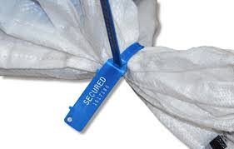
(Pic.1- example)
- Types of bags to be sealed – PP / recycling material preferred
- Color – no preference (please provide the options if existing)
- Breaking strength – minimum 45kg
- Security spring fixing – ultrasound
- Tightening loop – should be kept as small as possible to minimize the risk of intentional extraction.
- Bar code to include:
  - Unique consecutive series, as for example 450022624000
  - Laser print
  - The barcode must use the alphanumeric Code 128 symbology.
  - Number of characters: 12
  - Size - Length – min 3cm- max 4cm
  - Material & print resistant to temperature variation between -25 to 80 Celsius degrees
- RetuRO logo to be included

Technical drawing:
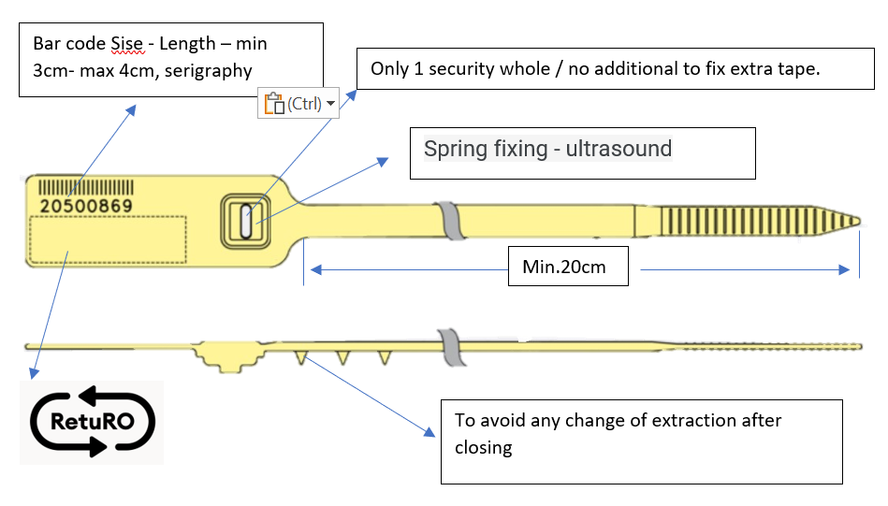

PROJECT SCOPE

RetuRO SGR is seeking proposals from qualified vendors for the supply of security seals for plastic bags. These seals are intended for secure and traceable packaging needs and must meet the highest standards of quality and reliability. Estimated volume: ~20 M pcs / year.

Tender deliverables
- Please provide the information required by, and in the format specified in, Appendix:
  - Vendor details
  - Commercial & Technical offers
  - Quality assurance & management
  - Pictures
  - Packaging Labels (for information)
- Provide max. 100 pcs as samples of the proposed models, delivered to the address mentioned in the first page, by second round deadline.
- Please provide details about your company’s risk management plan, if one is in place. Additionally, we would appreciate it if you could make it available for review.
- Please provide details about your company insurance policy (product liability, professional indemnity)

Request for Proposal and Project Timeline*

RFP publication | 13 March 2026
Q&A deadline | 20 March 2026
First round – offer submission deadline | 26 March 2026
Shortlist communication | 02 April 2026
Second round Q&A deadline (including possible site visit by RetuRO representatives) | 15 April 2026
Second round / Best and final offer submission deadline | 22 April 2026
Award | 30 April 2026
Contract alignment & signature | 31 May 2026

*The dates provided in this timeline are indicative and are subject to change at the sole discretion of RetuRO. They are not mandatory or legally binding and may be adjusted depending on internal approvals, supplier response times, or unforeseen circumstances.

Proposal Evaluation Criteria
The proposals will be evaluated based on the following criteria:

Evaluation criteria
Company Profile & Reputation:
Technical Requirements
Commercial conditions
Quality Assurance & Quality Management
Financial risk

We reserve the right to request additional information or clarification during the evaluation process. Please note that this RFP does not guarantee the award of a contract. All costs associated with the preparation and submission of the proposal shall be the vendor's sole responsibility.

Please do not use any other means of communication and do not directly contact directors or other Internal employees of RetuRO, members of Board of Director’s, members of the Supervisory Board, regarding this Competitive Offer Selection. Please address all your communication/additional requests directly to emails mentioned at "Single Point of Contact for this Competitive Offer Selection" point.

Any attempt to contact RetuRO by any method other than the one specified above may result in the bidder being excluded from the selection process, without further formalities. Any attempt to communicate through employees, members of the Board of Directors, or the Supervisory Board may be considered a serious breach and may lead to exclusion from the selection process, without further formalities.
If you have any questions or require further information, please contact Point of Contact presented at the beginning of this document.

